**Working with Various Properties of**

**Basic UI Elements**

**At the End of this Tutorial you will able to :**

* Understand various properties of basic UI elements(Label, Input , Button)

**Lets Start with the Label Properties :**

**PropertyName:** *design*

**PossibleValues:** Standard or Bold

Lets experiment with these values for Label

1. **Open your View and add the new property design in the Label tag as below**

<Label design=*"Standard "* text=*"Enter your First Name"*></Label>

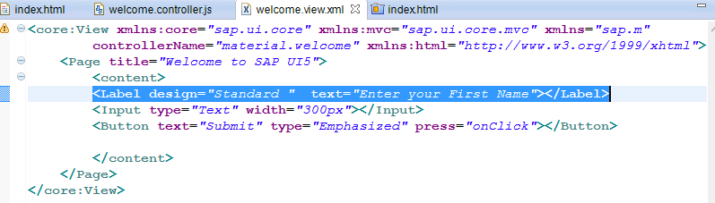

1. **Save All and Refresh the Browser**

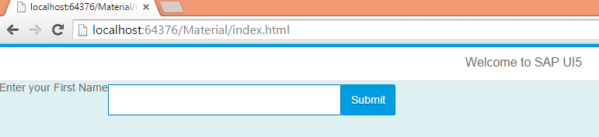

1. **Now Change the same property to "Bold" as below and see the difference in out put**

<Label design=*"Bold"* text=*"Enter your First Name"*></Label>

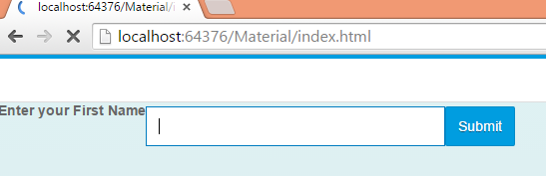

Identify the difference in the Label

1. **Now let's experiment with another property as below**

**property name :** requited

**possible value:** true or false

Open your view and add the above property as below

<Label design=*"Bold"* required=*"true"* text=*"Enter your First Name"*></Label>

Save all and refresh the web page

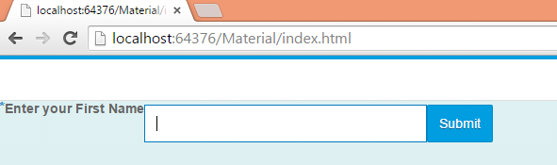

Observer the * before the Label

Now repalce with required ="false " as below and check the output

<Label design=*"Bold"* required=*"false"* text=*"Enter your First Name"*></Label>

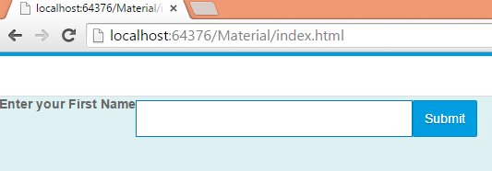

If you Observe * was gone before the Label

1. **Now Lets Experiment with Input field properties**

**property name: width**

**possiblevalues: some number in pixels or % example: 300px**

**Change the Input field tag as below**

<Input type=*"Text"* width=*"100%"*></Input>

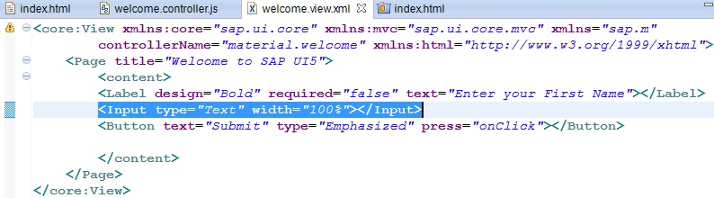

Save All and refresh the webpage you will find the out put as below

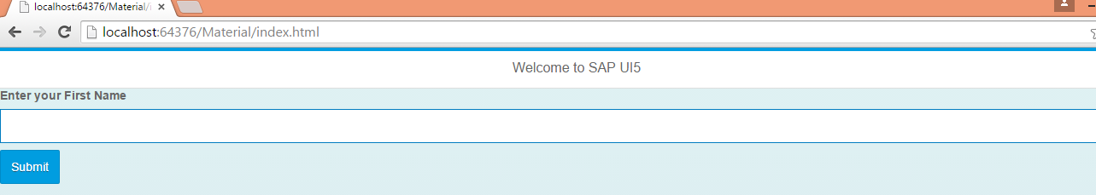

The Input field occupies the Entire screen

Now Again change it back to width="300px" as below

<Input type=*"Text"* width=*"300px%"*></Input>

Save all and refresh the webpage , you will find the result as below



1. **Restricting the user from entering more characters than specified limit :**

**we can restrict a user from entering more characters than a specified limit by using**

**"maxLength" peroperty .**

**poperty name:** maxLength

**possbile Values:** any integer number . ex: 10

**Now lets experiment with this property. Open the view and add the "maxLength=10" to <input> tag as below**

<Input type=*"Text"* maxLength=*"10"* width=*"300px"*></Input>

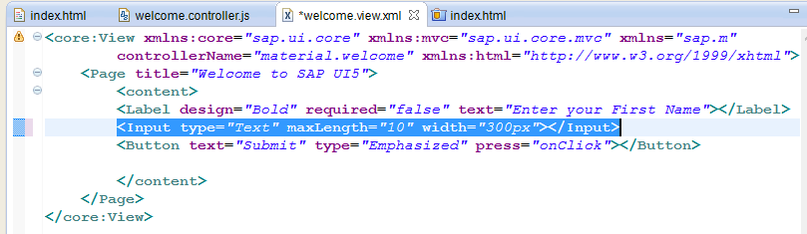

Save all refresh the browser. In the output try entering more than 10 characters

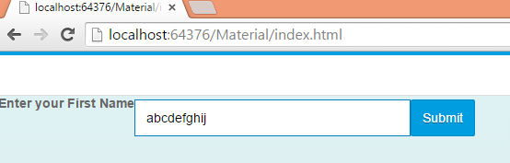

You can enter more than 10 characters .

1. **Lets see the next property now:**

**propertyname:** type

**possible values :** Text, Number, Email, Phone , Password

The property "type " will specify the type of the data entered . The possible values Number , Email , Phone help full to open the corresponding keypad in touch devices .For example if you mention the type="Number ' it will open the Number pad in touch devices , and if you mention type="email" then it will open the keypad with alphabets, numbers and @ symbols . This property has no effect for desktop .

So lets worl with Another possible value i.e type =" Password" This will change the character that are entered in this filed to dots **(".")**

1. **Open the View and add type ="Password" in the input tag as below**

<Input type=*"Password"* maxLength=*"10"* width=*"300px"*></Input>

save all and refresh the browser. All the characters will be **dots (.)**

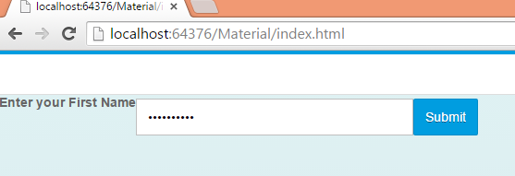

1. **Lets work with another property "enabled"**

**propertyname :** enabled

**possbile values:** true , false

**Open the View and add enabled ="false" in the input tag as below**

<Input type=*"Password"* maxLength=*"10"* width=*"300px"* enabled=*"false"*></Input>

save all and refresh the browser. You will find the input field disabled

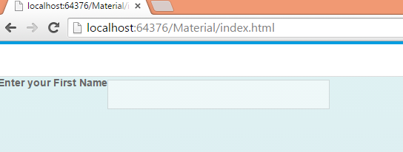

1. **Now Lets experiment with Button**

**property name :** width

**possbile values :** any digit in pixels or % Example : "100px"

1. **Open the view and add width="200px" in the Button Tag as below**

<Button text=*"Submit"* width=*"200px"* type=*"Emphasized"* press=*"onClick"*></Button>

Save all and refresh the browser .You will find the button width has been increased .

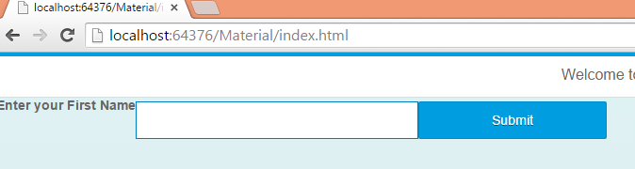

Now Lets experiment with the last property for Button

**propertyname :** type

**possbile Values :** Emphasized, Default, Accept, Reject, Back

1. **Open the view and add type="Accept" in the Button Tag as below**

<Button text=*"Submit"* type=*"Accept"* width=*"200px"* press=*"onClick"*></Button>

Save all and refresh the browser .You will see the button in Green color as below

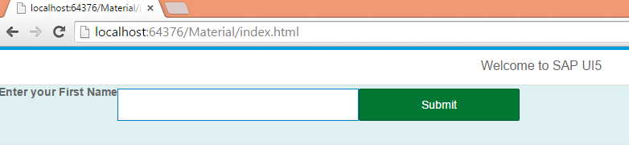

Similary you try with remaining types : Reject , Back, Default .

1. **Hiding and Unhanding the UI elements**

**You can hide and Unhide the any UI elements by using a property "visible"**

**propertyname:** visible

**possbile values :** true, false

Now lets Experiment with this property .

**Open the view and add visible ="false" for button**

<Button text=*"Submit"* type=*"Accept"* width=*"200px"* visible=*"false"* press=*"onClick"*></Button>

Save all and refresh the browser. You will find Button is hidden

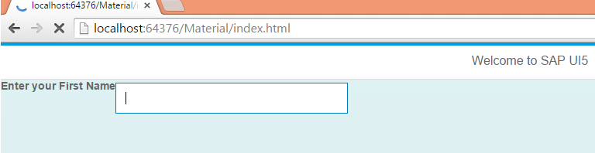

Now Again change it back to visible="true". Save all and refresh the browser . you will find the button is visible now.

